[Let the music play](https://www.youtube.com/watch?v=V3eOuK_-c34)

by José Carlos Duarte

November, 2016

Let the music play is an application created to make easier to play music from library or copy them to a folder or memory sharing with friends.

To people that have many files of music in the library, like me, it’s not possible to bring all of them with your mobile phone or player. Also, it’s a time consuming to decide which one to play.

Let the music play makes easier these tasks and other tasks to manage your music files.

See instructions next pages and enjoy.

To start you will need to install Java.

Java can be installed from:



Add java.exe to your path and use the command according.

To list all music files (*.wma and *.mp3)

*Java Main <music_folder>*

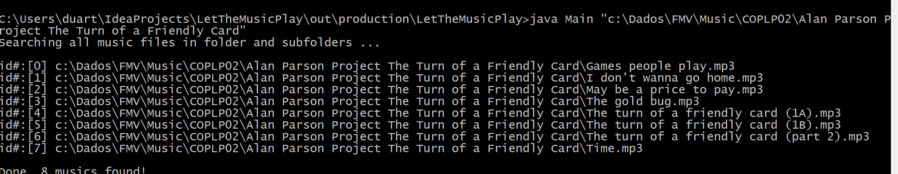

You can see above that every music will have an ID assigned. These IDs can be used to create a file with IDs to copy files like you will see next command options.

To shuffle some music files to play

*Java Main <music_folder> <num.music>*

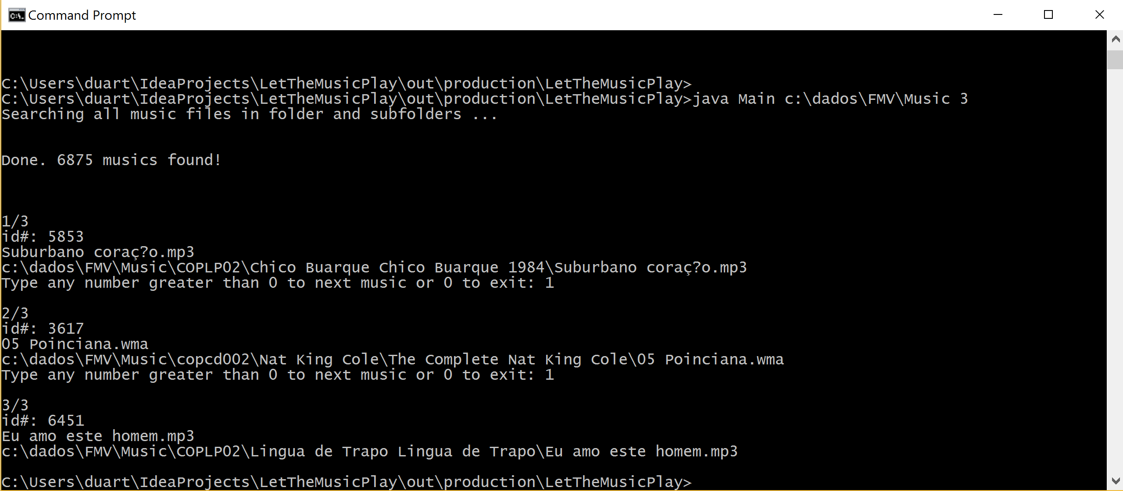

In the sample above 3 random music files were selected to play.

To play music files from a id list file

*Java Main <music_folder> <id list file>*

Note: To get ids list all files (first command)

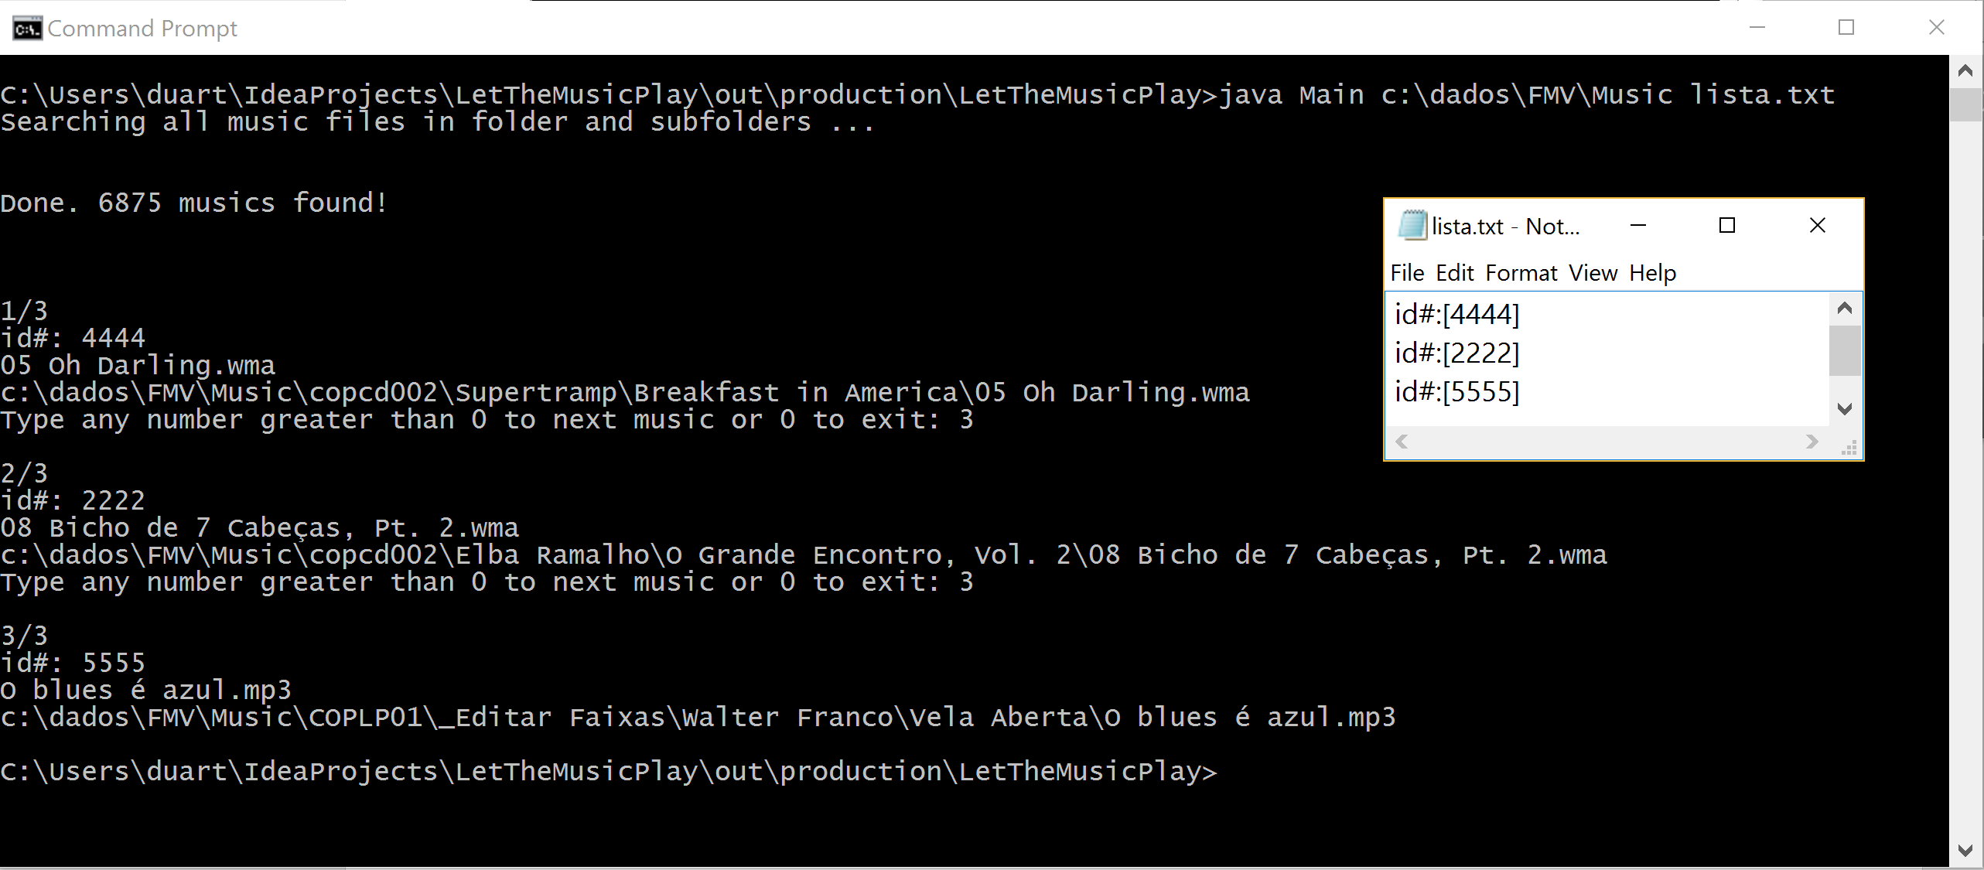

In the above screenshot, you can see 3 ids in the list and the 3 files with these ids were selected to play.

To shuffle some music files and copy to a folder

*Java Main <music_folder> < num.music > <target folder>*

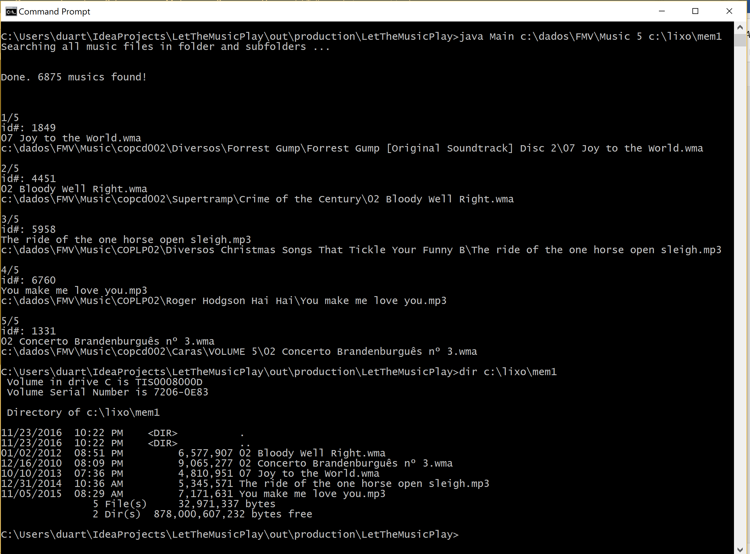

Above 5 random files were selected and copied to mem1 folder

To copy music files from a list to a folder

*Java Main <music_folder> < id list file > <target folder>*

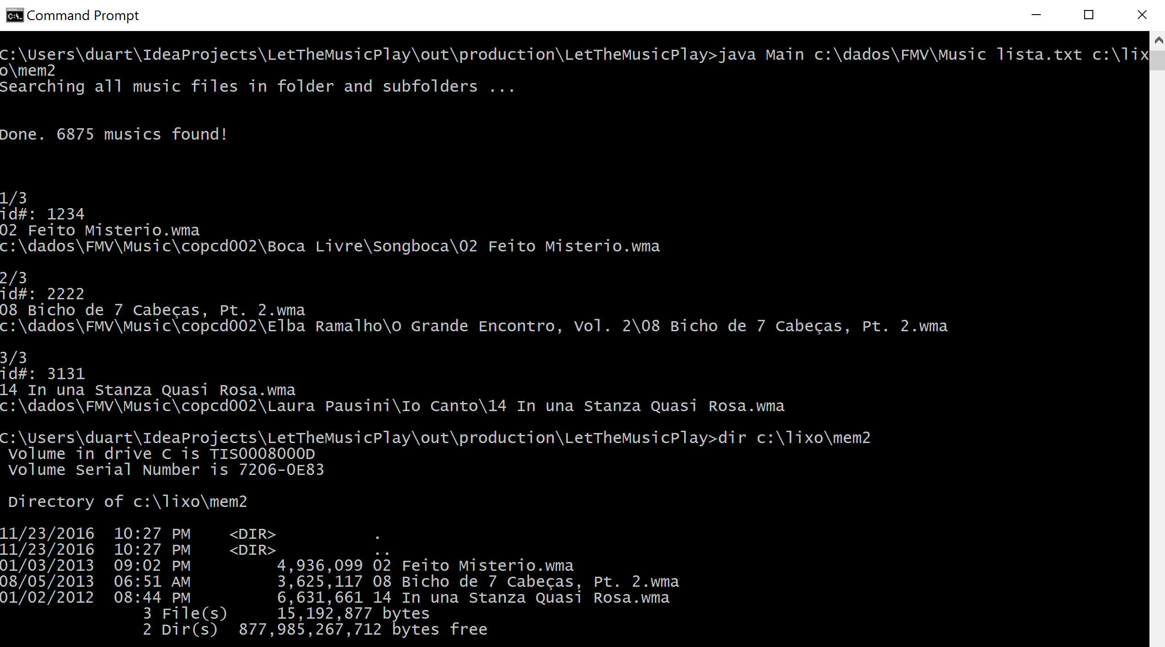

This time, 3 files selected in ID list file were copied to mem2 folder

To add sequence number to files copied to a folder

Use -n as last parameter like:

*Java Main <music_folder> < num.music > <target folder> -n*

*or*

*Java Main <music_folder> < id list file > <target folder> -n*

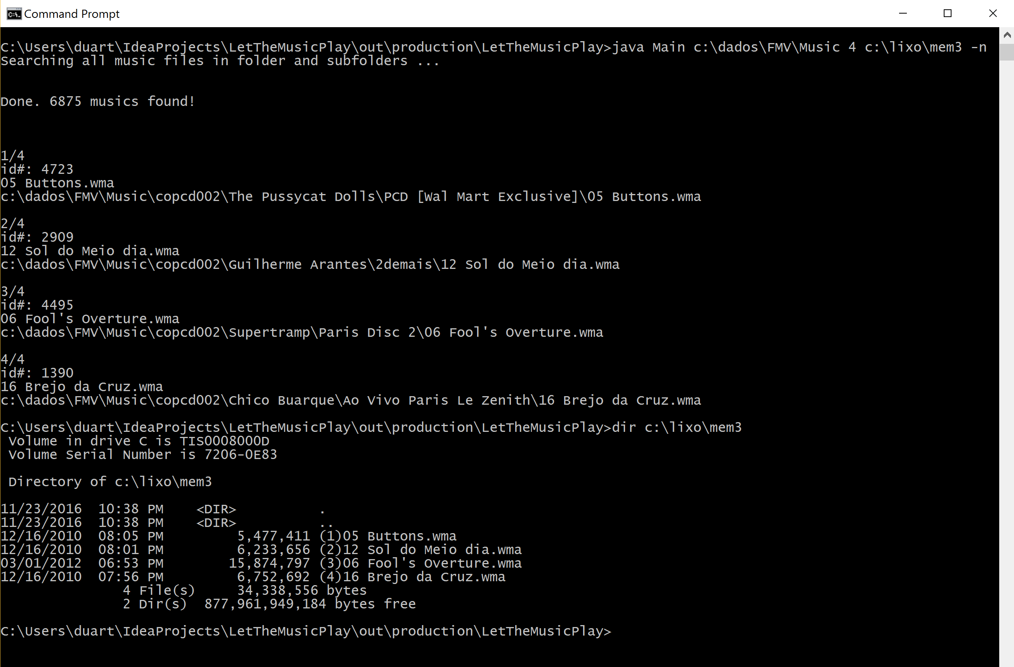

In the above screenshot, 4 random files were copied to mem3 folder with a sequence number in the name.

This option is useful when you cannot shuffle the music file in player or when the player reset the shuffle every time. In this case, you can listen the sequence, since the sequence is already a random selection.

To limit the number of files in a sub folder creating more folder according

To set a limit of music files in a folder use – and the max number of files to number of musics in the command, like:

*Java Main <music_folder> < num.music >-<max files/subfolder> <target folder> -n*

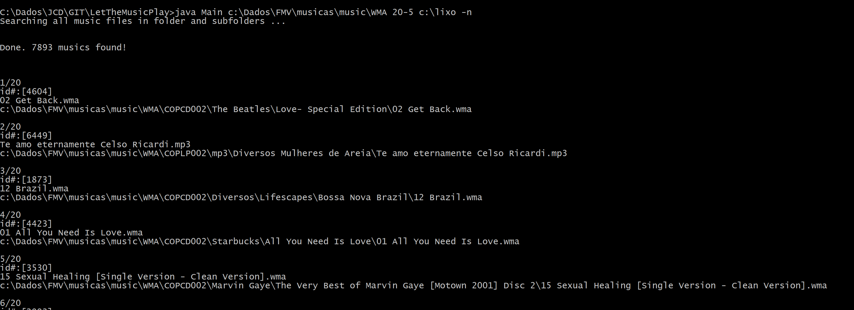

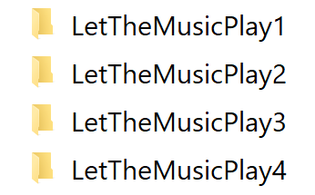

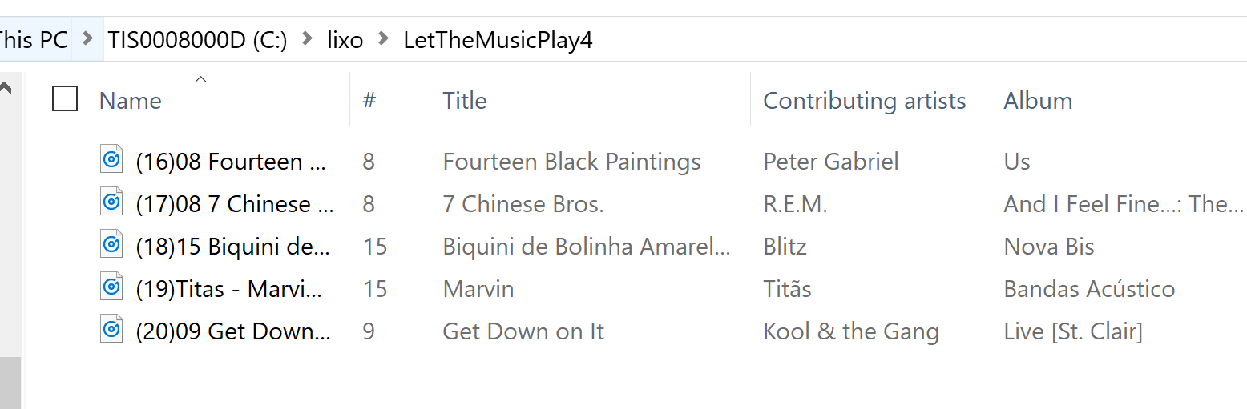

Above you can see a sample selecting 20 random musics creating (4)folders with 5 musics

Questions/bugs: email [duartejc2001@hotmail.com](mailto:duartejc2001@hotmail.com)

If you have not done yet, click in title of the document toknow where the name of this tool come from.